

UCN Computer Science

dmai0914

Group 5

1st Semester Project

Hand in: 02-06-2015

Table of Contents

- Project introduction - 3

Segment 1: BUSINES 4

- Organizational Structure - 4

- Evaluation of Organizational Structure and Problems - 6

- Organizational culture - 7

- Stakeholder analysis - 8

- Financial position - 9

- SWOT Analysis - 10

- Competitive situation - 11

- Logistics, supply chain and value chain - 12

- Vision and Mission - 12

- E-business and E-business Strategy - 13

- Strategic goals - 13

- Business case - 14

*Introduction 14*

*Management summary 14*

*Benefits and costs 14*

*Impacts and risks 15*

*Conclusion 15*

## - Project introduction -

This is the documentation file for our 1st year project. Its purpose is to explain all the details of the software we have produced along with the process of how it was made to give you the basic idea of our way of thinking during the period of time we were making it.

We were working for a pharmaceuticals company named “Entafarma” and were asked to design a software which would be more efficient than the one they had before. The software should be able to provide information about every single product available, show statistics, work faster than its ancestor, have a stable database and most importantly handle all the sales automatically instead of having workers to do it manually.

# Segment 1

# Business

## - Organizational Structure -

Entafarma was founded in Lithuania by Tauras Endriukaitis and two other people in 1993. He has been the C.E.O of Entafarma for the past twenty-two years. Next in line in terms of decision making is the executive director, the head of development and the marketing manager. Decision making is centralized amongst the four of them but the C.E.O. has to be informed about proposed decisions and he has the final say.

The company started out with three enthusiasts and currently has eighty two employees at its head office. The employees are grouped into four categories: logistics, pharmaceuticals marketing, wholesale pharmaceuticals and repackaging of medicinal products.

The company’s structure resembles Mintzberg’s The Machine Organisation (Bureaucracy). This is because machine organization is defined by its standardisation. The work at Entafarma is very formalized and there are many routines and procedures to be followed e.g. process of selling wholesale and retail to public and private pharmacies. [Ian Brooks, “Organisational Behaviour, 4th Edition”, p. 212-213]

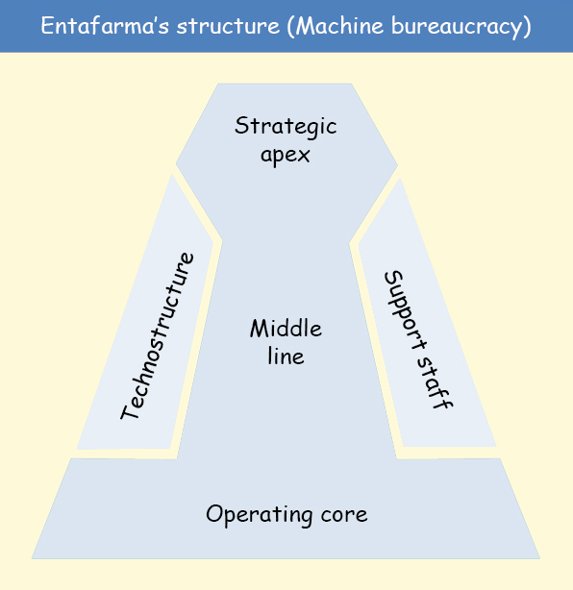

The tasks are grouped by functional departments. Each department and its head have a specific task that is assigned to them. For example, the head of the department of development is responsible of acquiring products from the supplier; the marketing manager is responsible for sales and there are I.T. employees who update the business data into the current system.

The company is an established organisation since it was established in 1993 and has expanded its markets in Lithuania, Latvia and Estonia. They sell their products all over Baltic countries.

Machine bureaucracy is based on performance organisations and not problem solving ones – they know what they have to do and their main concern is to get the best products and sell them. This is clearly evident in Entafarma.

One may reason that Entafarma’s organisational structure can also fall under the Professional Bureaucracy category. This is not the case. Entafarma’s decision making is centralized while in a Professional Bureaucracy structure the decision making is decentralized due to the presence of highly trained employees in a business – the manager or director can overlook everything. [Ian Brooks, “Organisational Behaviour, 4th Edition”, p. 213]

## - Evaluation of Organizational Structure and Problems -

While analyzing the Machine bureaucracy of this company, advantages and disadvantages have been discovered.

The first advantage of this structure is that there is no need for highly trained employees because of the repetitive tasks and work. The managers know exactly what they have to do and what they expect from all the employees. The workers are not given “problem solving” tasks, so they don’t have to manage big problems. For example, the IT people are responsible for updating the system with the data of the sales.

Another advantage is that the C.E.O. and the managers can overview everything in their company, allowing them to increase the overall quality of their services. Also, if an employee is not doing his work properly, the managers can check up on him to see what the problem is.

However, the disadvantage is that if a problem comes up, the employees can’t solve it themselves. They have to bring it to the managers first. The managers then might have to pass it even higher in the chain of management, resulting into a slow workflow until the problem is resolved by the management.

In addition to disadvantages, in this type of structure there are high chances of micromanaging employees due to tight schedules and deadlines. The employees may feel pushed around to do repetitive tasks without being fully in charge of those tasks. This de-motivates the employees causing poor performance, dissatisfaction and decrease in revenue.

Also, they will confront big changes in society. Because this kind of bureaucracy is perfect for companies that are “static”, every change will cause difficulties because of their standardized schedule. [<http://www.lindsay-sherwin.co.uk/guide_managing_change/html_change_strategy/07_mintzberg.htm>].

Overall, the Machine bureaucracy structure fits the company’s needs thanks to its standardization and methodical work. It is important that all the decisions must go to the superiors because people are working with medicines.  As a result, the Machine bureaucracy’s weaknesses are used as strengths here.

## - Organizational culture -

Entafarma’s organisational structure resembles Role Culture. There is a high level of bureaucracy and formality within the organisation. [Ian Brooks, “Organisational Behaviour, 4th Edition”, p. 267] The company has three senior managers: an executive director, a head of development and a marketing manager. They control and coordinate their own departments, but most of the decisions have to be approved by the C.E.O. Rules, procedures and job descriptions are clearly defined and closely followed by everybody in the company. Work is rationally allocated to employees according to their departments, job descriptions and skills.

The company has been active in the field since 1993. Over the 22 years of its existence, it has continuously expanded and improved. As a result, the business is well established and has created a stable environment for its employees. Thus the Role Organisational Culture embraced by the company is providing security and predictability for the staff, being the most suited for Entafarma.

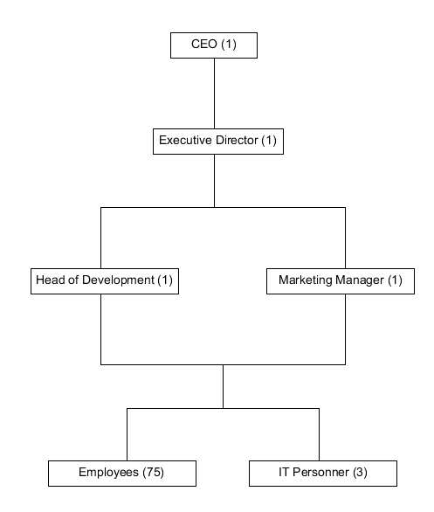

## - Stakeholder analysis -

Below is a stakeholder analysis grid for Entafarma. It indicates the goals, likely behaviours, reactions and future actions of the company’s stakeholders in regards to the new system. [Wendy Bloisi, “Management and Organisational Behaviour”, p. 98].

This analysis is used to depict ideas of how the stakeholders will react to the new system and how to implement and optimise the system to a suitable standard for all the stakeholders.

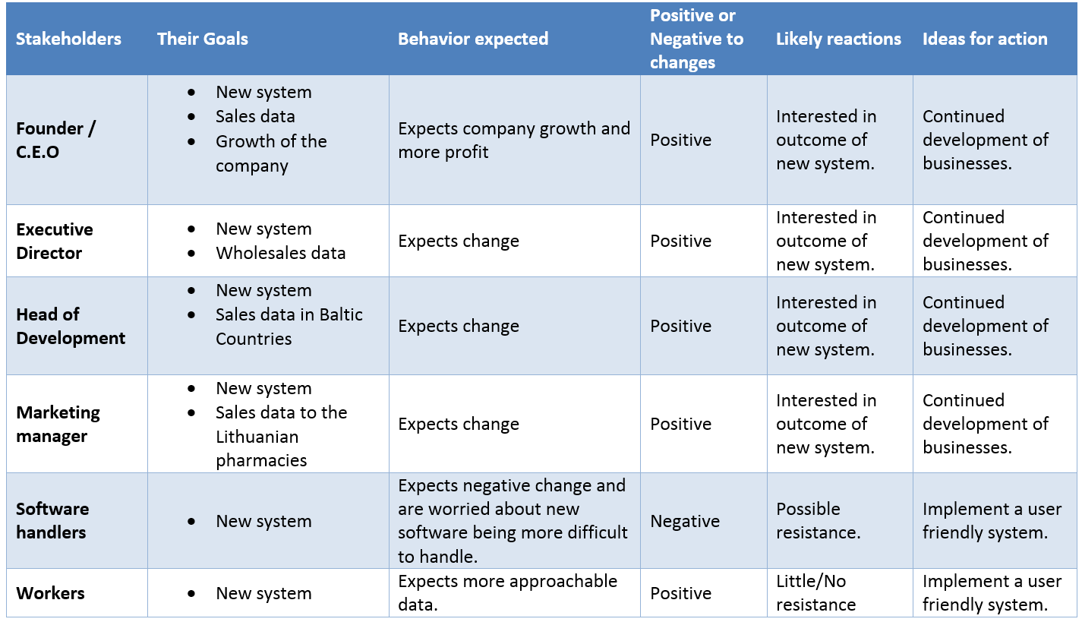

## - Financial position -

Due to the company’s policy, access to Entafarma’s private balance sheet was not granted. The only financial statement available contains data in regards to sales made between the 52nd week of 2014 and 8th week of 2015 (10 weeks).

The data from the financial statement is visually represented in diagram below (number needed).

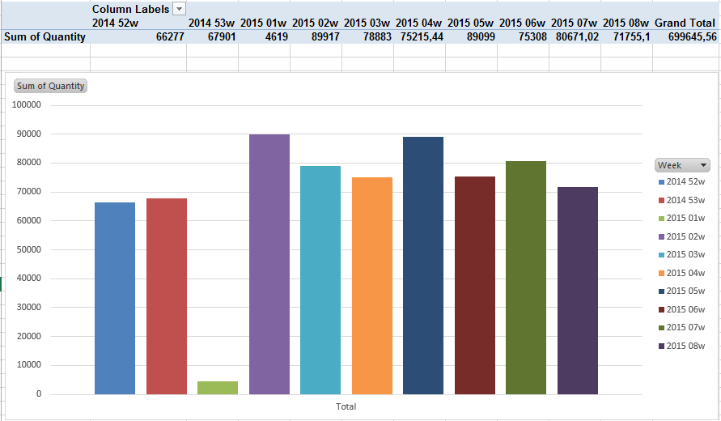

As seen in the above graph, the sales for the last 2 weeks of year 2014 are below the sales of every other week of the year 2015. The first week of 2015 is an exception. This indicates a bullish trend in Entafarma’s sales. Due to public holidays and people’s general preoccupation with the festivities, the sales were almost nonexistent. However, the week after, the sales hit a historical high in the history of the company as confirmed by the company’s CEO. [Erik Krogager, Jette Lauritzen, “Management accounting, financial measurement and planning”, p. 98-99]

This indicates that Entafarma’s financial situation is stable at the moment and  possibly in the near future presenting the company with opportunities like expansion into Baltic countries and diversification of services and products, as stated in the SWOT Analysis.

## - SWOT Analysis -

This diagram shows the strength and desirable future for the business. On the left side there are internal strengths, external opportunities and on the right are the internal weaknesses and external threats. [Wendy Bloisi, “Management and Organisational Behaviour”, p. 87, 111] [Erik Krogager, Jette Lauritzen, “Management accounting, financial measurement and planning”, p. 35-36]

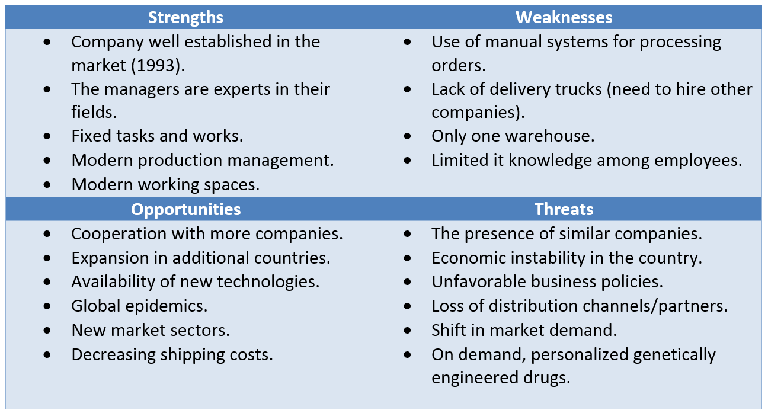

This SWOT Analysis is related to the company’s current financial position and strategic goals as it is evident that the company has funds to implement things like expansion into Baltic countries and enter new market sectors.

## - Competitive situation -

Porter considers the business world as a competitive environment where the position of a company in the market is determined by five forces. Having a good understanding of where the power lies enables Entafarma to take advantage of its strengths and improve on its weaknesses.

[Erik Krogager, Jette Lauritzen, “Management accounting, financial measurement and planning”, p. 33-35] [Michael E. Porter, “Competitive Strategy: Techniques for Analyzing Industries and Competitors”, p. 4]

1. New entrants - the barriers of entry into Entafarma’s market are extremely high. The huge costs associated with setting up a company in the pharmaceutical industry  together with the strict laws imposed by the government in this field, renders the threat of new entrants almost inexistent. Also, for a new company to get all the necessary paperwork, combined with the knowledge required to do so, raises another barrier of entry. Thus giving Entafarma a favourable position.
2. Substitute products or services - DNA sequencing cost has continuously decreased, outpacing Moore’s Law beginning in January 2008. The cost per genome has gone down from $100M in 2001 to ~$5K in 2014 [<https://www.genome.gov/sequencingcosts/>]. In the following years it is expected that backward-looking medicine will be replaced by forward-looking medicine. Today, a person gets sick and goes to a doctor for treatment. Tomorrow, people’s DNA will be analyzed and any genetic vulnerabilities will be flagged, allowing doctors to give patients personalized medications based on that person’s DNA, not to treat them, but to prevent the appearance of a disease anticipated by the DNA test [<http://www.businessinsider.com/super-cheap-genome-sequencing-by-2020-2014-10>]. This will completely change the pharmaceutical market. The companies basing their businesses on selling traditional drugs, including Entafarma, will find themselves out of business.
3. Suppliers - Entafarma has 5 main suppliers based in separate countries, continents and operating under different laws. With such a range of suppliers, the company has a number of  choices when buying a product. The suppliers are fighting for doing business with Entafarma, allowing it to buy at low prices and within good conditions. Because of this, suppliers do not have much power and control over Entafarma.
4. Buyers -. Entafarma has contracts with approximately 1400 pharmacies from Lithuania, 6 wholesalers and approximately 900 doctors. The contracts are usually made for an entire year, making it hard for customers to switch from Entafarma to another supplier. On top of that, customers get discounts based on the total amount of money spent on the company’s products and services. This creates a huge advantage to keep doing business with Entafarma rather than switching over to another competitor.
5. Competitive background - Entafarma is the top 2 pharmaceutical company in Lithuania. Their main competitors are Sirowa, Orkla, Valentis and Walmark. Orkla is currently the only company surpassing Entafarma in terms of business. Even though Entafarma and Orkla are very similar in their offerings, Orkla is considered to be the leader in the market. This is due to their focus on advertising. Most of Entafarma’s customers have been with the company for a number of years, making them loyal and valuable. The company is basing its business on already existing customers, giving them discounts and helping them grow, thus allowing entafarma to grow along.

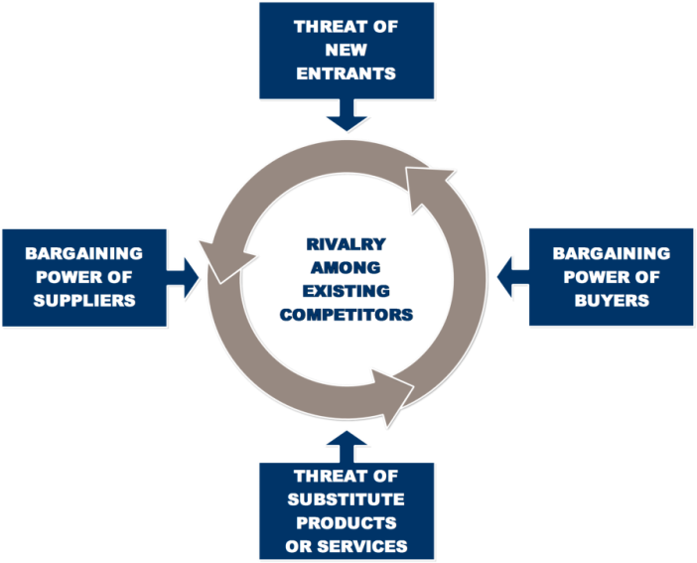

## - Logistics, supply chain and value chain -

Entafarma has 5 main providers: Pinewood, Lepicol, Vitabiotics, Zentiva Aloe and Beres.

The company places a huge order to its suppliers, thus guaranteeing them a discounted price. The order is then shipped to Entafarma warehouse (number needed). At the warehouse the products are transferred to their respective shelves and stored under the right conditions of temperature and humidity. [Dave Chaffey, “E-Business and E-Commerce Management: Strategy, Implementation and Practice”, p. 335-348]

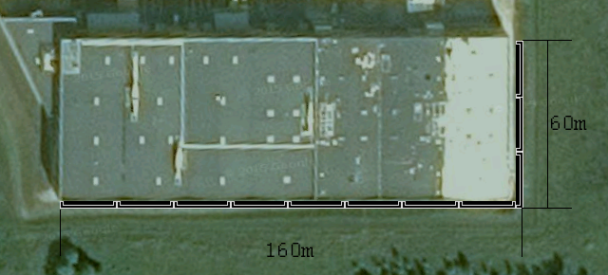

Some of the products go through an extra step of repackaging. Old labels are removed and equivalent translations are added, according to the language of the countries they are going to ship the products to. [Dave Chaffey, “E-Business and E-Commerce Management: Strategy, Implementation and Practice”, p. 348-353]

When the product is ready for delivery, it is assigned a price.

In the last step the products go from the warehouse to the customers. Entafarma has contracts with a range of shipping companies. When an order is made, the products are packaged and prepared for delivery. The shipping company ensures that the drugs are transported in proper condition and that they reach the customer undamaged.

The payment is received according to the contract in place. Usually, customers pay on a 30-day basis, while some of them pay for each order before or after its delivery.

## - Vision and Mission -

**Vision** [Wendy Bloisi, “Management and Organisational Behaviour”, p. 76-77] [http://entafarma.lt/en/about-us]

“*Basics of Justice: To harm no one and benefit the society.*” - Cicero

**Mission** [Wendy Bloisi, “Management and Organisational Behaviour”, p. 76] [http://entafarma.lt/en/about-us]

*“To develop services according to the tendencies and needs of the market, to build-up complex services, reliable partners, qualified and loyal collective.”*

## - E-business and E-business Strategy -

E-business is the conduct of business processes on the Internet. Most companies take advantage of the continuously growing online environment to increase their business. By establishing an online presence through social media, online advertising, online shops, enterprises seek to increase brand awareness, attract more customers and expand into new areas. [Dave Chaffey, “E-Business and E-Commerce Management: Strategy, Implementation and Practice”]

Entafarma has established an online presence through their website  (<http://entafarma.lt/>). In 1998 the company acquired the domain with the same name. The website has been online ever since. [Dave Chaffey, “E-Business and E-Commerce Management: Strategy, Implementation and Practice”, p. 78-79]

Even though Entafarma is mostly taking orders over the phone, the website is an important part of their business. The website features general information and contact information about the company and helps increases trust among prospective customers.

Available both in English and Lithuanian, the content on the website is easily understood by the majority of the targeted customers.

Email is another part of Entafarma’s online strategy. Customers can order products, as well as receive support or request more information through email. [Dave Chaffey, “E-Business and E-Commerce Management: Strategy, Implementation and Practice”, p. 131-132]

Due to the “Machine Bureaucracy” strategy, a complete e-business innovation, would bring with it big changes in the company. This can lead to slow progress in the beginning due to the strict protocols and rules.

For the near future, the company has no plans for developing an online shop. Because of it’s B2B model, customers acquisition is done directly and contracts with other businesses are signed years in advance. This makes the existence of an online shop not useful at the moment.

## - Strategic goals -

The strategic goals outlined here are to be achieved by implementing this proposed software system. They are closely related to the company’s long-term mission. [Wendy Bloisi, “Management and Organisational Behaviour”, p. 74-75]

1. Reduce the time needed by warehouse operators to handle the orders.
2. Expansion into new countries.
3. Increase the number of orders that can be handled in a short timeframe.
4. Increase customer retention.
5. Increase the quality of services.
6. Generate meaningful statistics.
7. Develop and use a customer database.

## - Business case -

### Introduction

In order to remain competitive in the pharmaceuticals market, Entafarma needs to stay ahead of competition. An improved IT system is required to optimize workflow across departments, reduce costs and offer a better overview of current operations. [Schmidt, Marty J, “The Business Case Guide, 2nd Edition”]

### Management summary

Currently, everything is done manually. The only use of IT is once a month, when the IT department inputs the sales from the previous month into a spreadsheet. The process is slow and inefficient.

To solve this issue, the following options were considered but not chosen:

1. Hire more people to make the current bookkeeping process faster and to manually generate useful data for the executives. This option is not recommended because it involves high costs. On top of that, it is not scalable.
2. Give all employees access to current database. This is not recommended because it requires a computer for every employee and it raises security problems. Also, all the employees would be required to learn to use the system.
3. Buy an IT system. Not chosen because it would not be fully compatible with the company’s needs and structure.

It has been concluded that a new, custom-made IT system is the best option. It will improve workflow across all departments, reduce costs, provide live info of the current sales situation and allow for better scalability.

### Benefits and costs

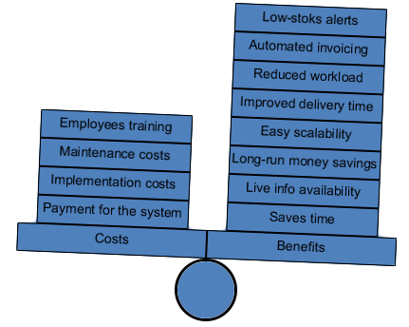

[Boardman, Anthony E, Greenberg, David H, Vining, Aidan R and Weimer, David L, “Cost–Benefit Analysis: Concepts and Practice, 2nd Edition”]

### Impacts and risks

The change to a new IT system poses a number of risks. The negative impact generated by the time needed for the staff to learn the system is only short-term. After the end of the adjustment period, the negative impact will no longer exist. This risk can not be avoided but its effects can be reduced. By offering training to the staff, the adoption time can be significantly reduced.

### Conclusion

Because of all the reasons enlisted above, it is highly recommended for Entafarma to invest into the proposed IT system. It will definitely benefit the company in the long-run, as well as offer significant advantages starting from its adoption.